**Asynchronous Messaging**

1. Rabbit MQ ( <https://github.com/Java-Techie-jt/springboot-rabbitmq-example> )

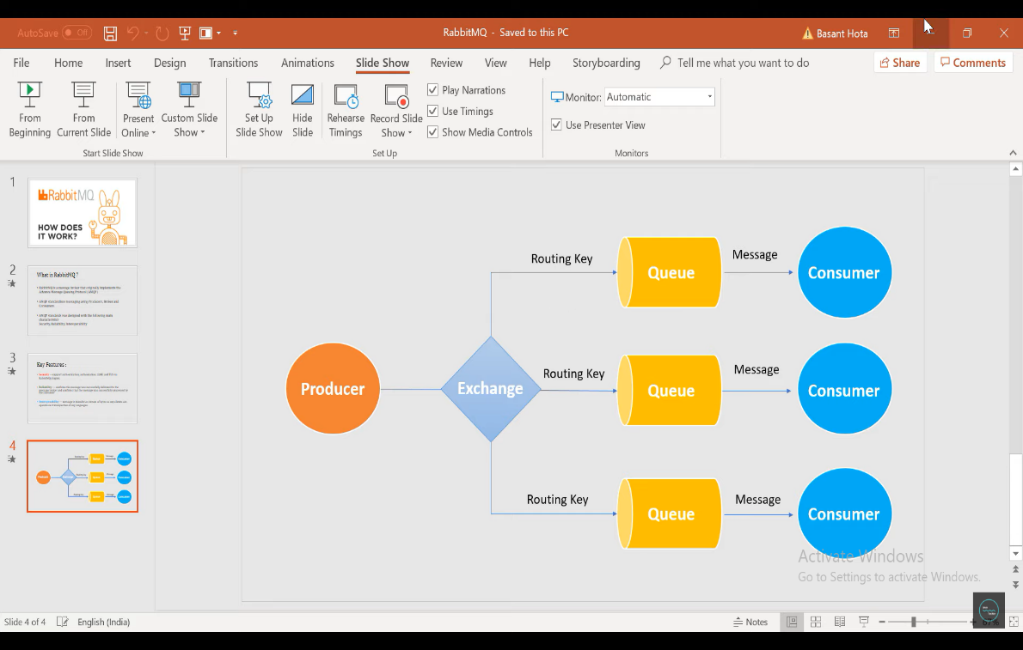

The RabbitMQ architecture includes producers, exchanges, queues, and consumers. A producer pushes messages to an exchange, which then routes messages to queues. A consumer then continues to read messages from the queue. Once it is read by consumer, it will be removed by queue.

**Steps to install RabbitMQ**

1. Download and install ERlang <http://erlang.org/download/otp_win64_22.3.exe>
2. Downlaod and install RabbitMQ <https://github.com/rabbitmq/rabbitmq-server/releases/download/v3.8.8/rabbitmq-server-3.8.8.exe>
3. Go to RabbitMQ Server install Directory C:\Program Files\RabbitMQ Server\rabbitmq_server-3.8.3\sbin

Note: Open cmd in run as administrator

1. Run command
   1. rabbitmq-plugins enable rabbitmq_management
   2. rabbitmq-service.bat start
2. Open browser and enter <http://localhost:15672/> to redirect to RabbitMQ Dashboard
3. Login page default username and password is guest
4. After successfully login you should see RabbitMQ Home page

Note: Did not work

1. Kafka

It is the publish-subscribe based durable messaging system. It consists of Producer, Consumer, Cluster, Broker, Topic, Partition. Cluster will have many brokers. Broker will have many tokens. Topic will have many partition. There will be zookeeper which manages the brokers. There will be replica of brokers. If one broker fails, replica will be used. The message/record will be stored in leader broker first, it saves the record and increments the offset (Each record/message will have unique offset). Replica brokers will follow the leader broker. When leader broker fails, one of the replica broker will be leader broker. When there is multiple partition in the topic, by default it will follow round robin to save the message. If we want the message to be saved in same partition, we can attach the key to the record/message, saying to which partition the message should go to. The data sent is stored for specified time.

Note: Broker means kafka server which is running.

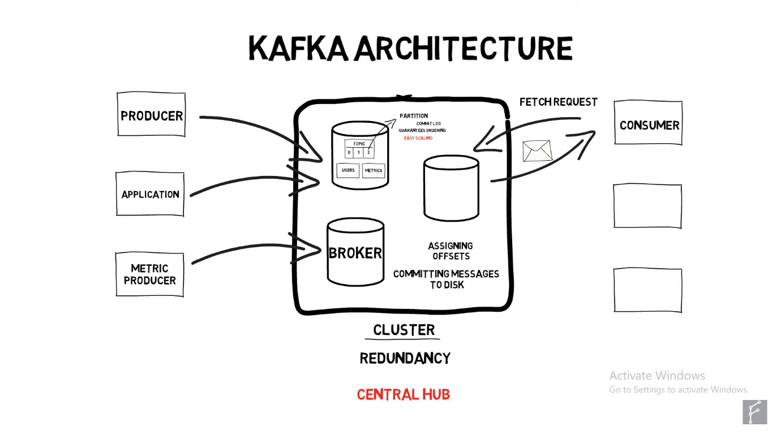

Costumers can be grouped to form costumer group and take message from particular partition.